We can see that, Louis Vuitton’s average Brand equity over years (2001-2021) is the highest which is 20867.857 and the second highest average brand equity is the nike which is 18403.428.

Let us see the how Louis Vuitton and Nike’s Brand equity changed over years.

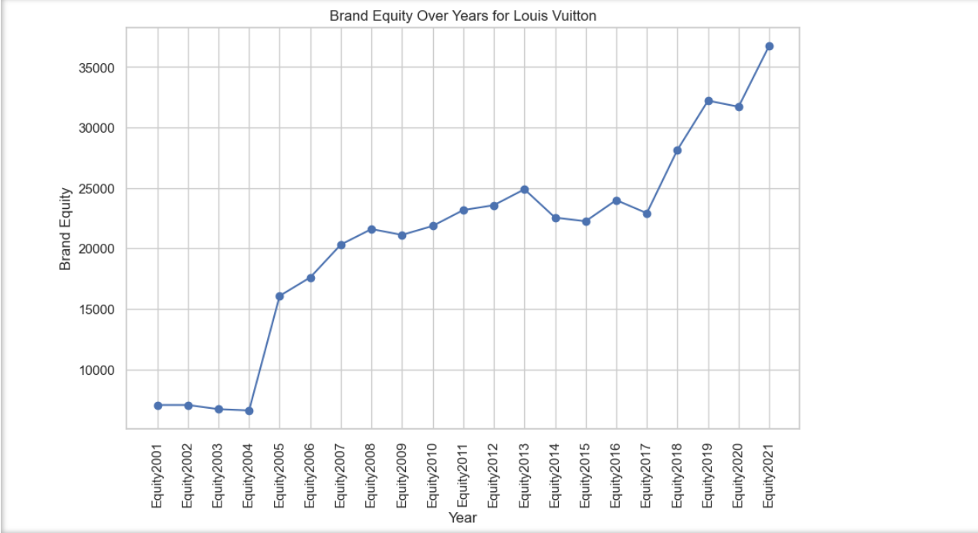

Examining how brands from different countries perform on the global stage.

Sweden has the highest brand equity among other countries but we have only one brand coming from Sweden which is H&M.

Brands from U.K have highest ranking among all other countries’ brands.

Spain brands have the best growth rate

Louis Vuitton has the highest growth rate.

